

Radiant panels

**SR II**

**1 stage type : 21 - 31 - 41 - 61 – 81**

**2 stages type : 42 - 62 – 82**

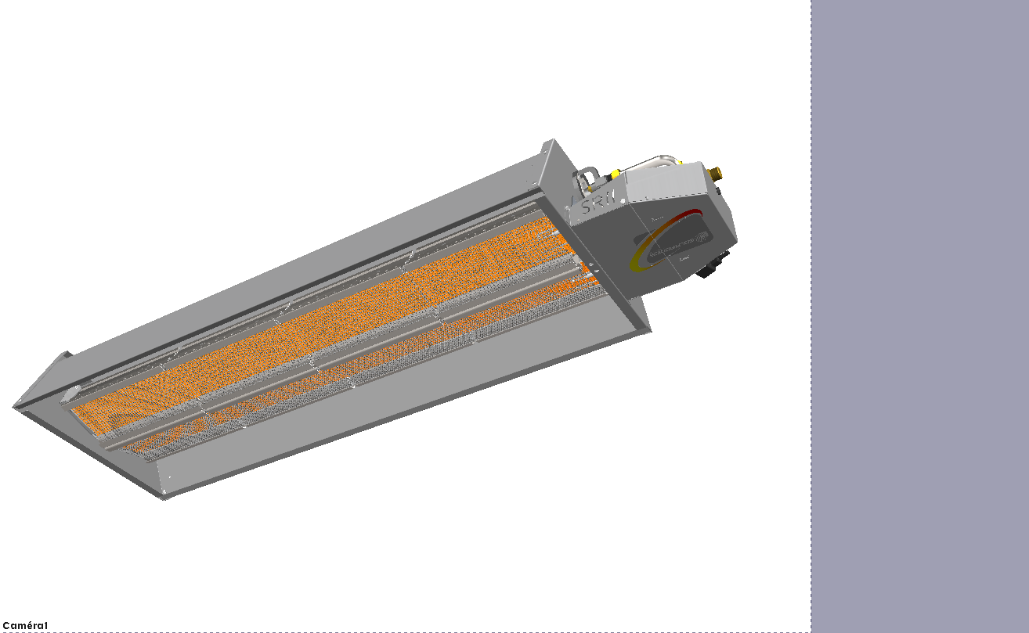

**« Standard » model**

**« Cased » model**

**« Places of worship » model**

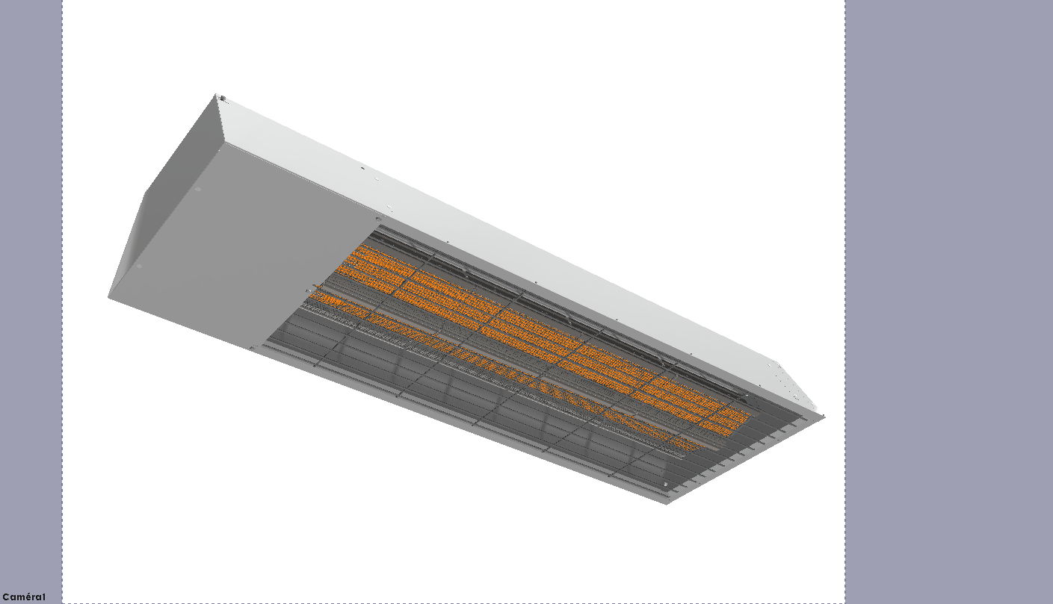

Content

1. Introduction 4

1.1. General 4

1.1.1. Manufacturer’s liability 4

1.1.2. Installer’s responsibility 4

1.1.3. User ‘s liability 5

1.2. Certifications 5

2. Safety instructions and recommendations 6

2.1. Safety instructions 6

2.2. Recommendations 6

3. Description 8

3.1. Main parts 10

3.1.1. Standard model 10

3.1.2. Cased model 11

3.2. Gas line 12

3.3. Operating cycle 13

4. Technical data 14

5. Overall dimensions 15

5.1. Standard models, with the ½" male connexion from the flexible piping kit 15

5.2. Cased models, displayed with the flexible piping kit 15

6. Installation of the appliance 16

6.1. General rules 17

6.2. Implantation 18

6.2.1. Recommended hanging heights 18

6.2.2. Tilt 18

6.2.3. Handling for hanging 19

6.2.4. Hanging 19

6.2.5. Combustion products and ventilation of the premises 19

6.3. Gas connection 20

7. Temperature control - electrical connection 22

7.1. Temperature control 22

7.2. Electrical connections 22

7.2.1. Connections 22

7.2.2. Wiring diagram of the control and safety box 24

8. Commissioning 26

8.1. Start-up 26

9. TROUBLESHOOTIONG 27

9.1. Troubleshooting 27

9.2. Spare parts 29

10. Maintenance 30

10.1. Sequence of operations 30

10.2. Maintenance operations 30

10.2.1. Cased models: Removal of the casing 30

10.2.2. Inspection of radiant surface 31

10.2.3. Electrodes 31

10.2.4. Cleaning of the mixer and injector 31

11. Warranty 32

12. Information 34

APPENDIX 50

End of life of equipment 50

The right thing for the safety 50

Smell gas? Good reactions! 50

1. Introduction

In this manual, the warnings are used to point to specific information. We want to ensure the user safety, to avoid any problem and to ensure proper operation of the appliance....

** WARNING**

Indicates a potential hazard which can cause bodily injuries and/or material damage

 Indicate important information.

 Indicate a reference to other notices or other pages of the manual.

 Before installation and commissioning the device, read carefully all enclosed notices.

* 1. General
     1. Manufacturer’s liability

Our products are manufactured in compliance with various applicable European directives requirements. They are thus supplied with EC markings and all necessary documents. With our commitment to quality products, we constantly seek to improve them. We therefore reserve the right at any time to modify the characteristics stated in this document.

Our liability as a manufacturer does not apply in the following cases:

* Failure to follow operating instructions for the appliance.
* Failure to maintain or insufficiently maintain the appliance.
* Failure to follow installation instructions for the appliance.
  + 1. Installer’s responsibility

The installer is responsible for installation and first commissioning of the device. The installer must observe the following:

* Read and follow the instructions given in the instruction manuals provided with the device.
* Carry out installation in accordance with the applicable legislation and standards.
* Carry out the first commissioning and carry out all necessary controls.
* Explain the installation to the user.
* Inform the user that he cannot make changes in the appliance’s design and to the installation by himself. The slightest modification (change, removal...) of security components or parts automatically results in the appliance’s CE marking becoming invalid.
* Alert the user about the obligation to control and maintain the device.
* Hand all documents to the user.
  + 1. User ‘s liability

To ensure correct operation of the appliance, the user must observe the following:

* Hand all documents to the user.
* Read and follow the instructions given in the instructions manuals provided with the device.
* Call in a qualified technician to carry out the installation and perform the initial commissioning
* Obtain explanations about the installation by Installer
* Carry out checks and required maintenance.
* Keep all documents in good condition and near the appliance.
  1. Certifications

|  |  |
| --- | --- |
| Appliance | Radiant panel |
| Directive | 2009/142/CE « Appareils à gaz » |
| Gas category | II2Esi3P (France) |

1. Safety instructions and recommendations
   1. Safety instructions

** WARNING**

The radiant panel appliance is a live device and must be grounded during installation

* It is not allowed to obstruct and/or reduce the space reserved for the room or the appliance vents
* Do not obstruct smoke exhaust or fresh air suction ducts,
* Do not make any change in the settings made by the qualified technician
* Do not place or hang anything on the device,
* Any work on the appliance is prohibited before it is unplugging it from the mains and cutting the gas supply.
* Do not change the used gas type, camera, security systems or control settings, as this could lead to dangerous situations.

Call a qualified technician in the case of gas replacement, change of gas pressure or modification of power supply. If the appliance do not operates for a long period, disconnect the power supply of the appliance. When commissioning, it is advisable to use the service of a professional technician. Generally, all repair or maintenance works must be carried out exclusively by authorized and qualified personal.

 Subscribing to a maintenance agreement is strongly recommended

* 1. Recommendations

The radiant panels of the range SRII are dedicated to the heating of industrial and tertiary premises.

The highest attention will thus have to be brought during their installation and during their setting-up.

 We recommend entrusting their commissioning to Solaronics Chauffage.

The maintenance of the devices must be made every year, so as to guarantee their availability, to maintain their high performance level and also their safety of functioning.

** WARNING**

Only qualified professionals are authorized to modify and install the appliance.

* This information forms an integral part of the appliance and must always be kept always with the appliance, even in the event of transfer to another owner or user
* Do not remove or cover the labels and material safety data plates fixed to the devices. Labels and material safety data plates must be readable throughout the device life.
* Install the device in a sufficiently ventilated room, except if it has a tight connection
* Please contact us for any other application other than those described in this document

 **WARNING**

DON’Ts:

Do not install radiant panel appliances:

o Outdoor

o In environments with explosive risks,

o Premises containing vapors of chlorinated products

o In extremely wet premises (electrical shock hazards)

1. Description

Any object at a temperature above absolute zero emits energy in the form of electromagnetic radiation.

These rays travel in a straight line and may be reflected and converted into heat when hitting a solid.

These rays are called infrared wherever temperatures emitted are of the order of a few hundred degrees.

As it does not heat the air, the method is particularly well suited for buildings of:

* + - large volume,
    - not or poorly insulated,
    - large air renewals.

or, in any other buildings that requires:

* + - intermittent heating,
    - area heating.

The SRII radiant panel is a "direct" overhead heating system, burning natural gas or propane.

It generates heat through infrared radiation, the air needed as a combustive is sucked in from ambient atmosphere and the combustion products are subsequently released into the surrounding atmosphere. 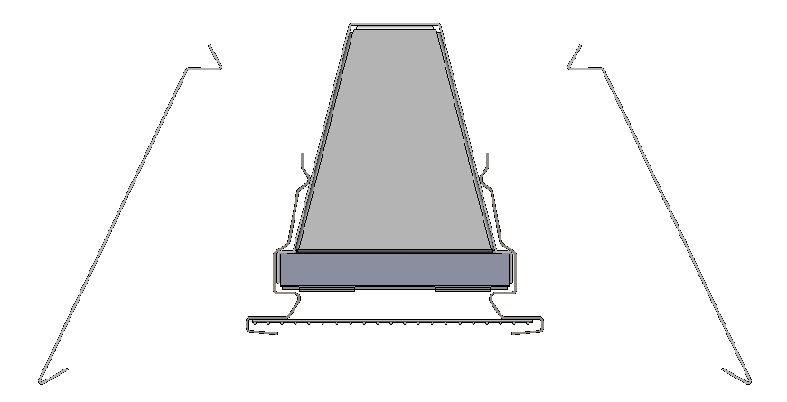

**1**

**2**

**4**

**3**

The panel burns gas on the surface of a wafer thin ceramic plate. (1)

A refractory steel grid makes it possible to tap some of the energy contained in the combustion products while increasing thermal exchanges between the flame and the plaque. (2)

When heated, the ‘grid-plaque’ assembly emits infrared rays directed towards the bodies to be heated by the reflectors. (3)

Combustion products go along the premix chamber which increases the performances of the device by preheating of the mixture combustive. (4)

The SRII 21, 31, 41, 61 and 81 operate on a one-speed basis (on/off).

The SRII 42, 62, 82 models, which include two burners, allow a two-stage operation (100 %, 50 % of the rated power). If the heating demand is low one burner only will come on which spells increased comfort for the user while reducing energy consumption.

A "Places of worship" model particularly silent is available for all the models of the range.

A "cased" model offers an esthetic solution of the standard or "Places of worship" model.

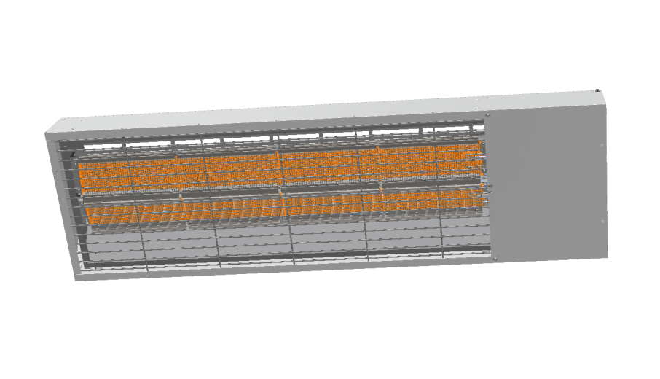

* 1. Main parts
     1. Standard model

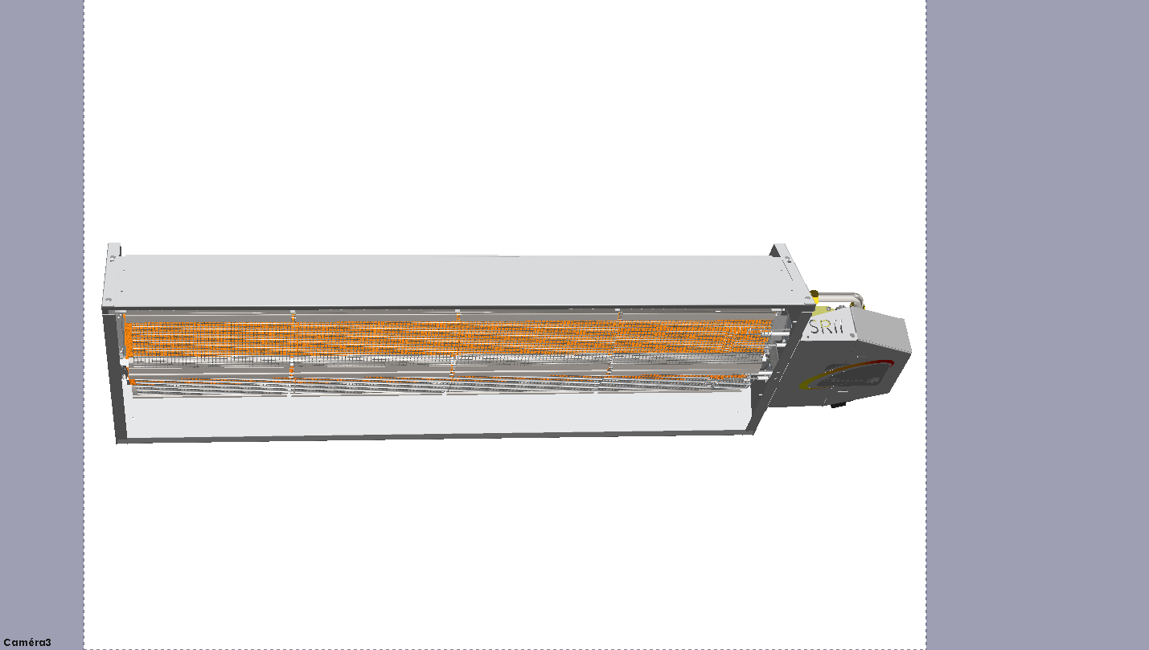

|  |  |  |  |
| --- | --- | --- | --- |
| **REP** | **Designation** | **Quantity** | **Remark** |
| 1 | Gas line | 1 | See details below |
| 2 | Safety and control box | 1 |  |
| 3 | Burner | 1  2 | SR II 21, 31, 41  SR II 42, 62, 82, 61, 81 |
| 4 | Side reflector | 2 |  |
| 5 | End reflector | 1 |  |
| 6 | Electrodes | 1  2 | SR II 21, 31, 41  SR II 42, 62, 82, 61, 81 |

* + 1. Cased model

*Top view:*

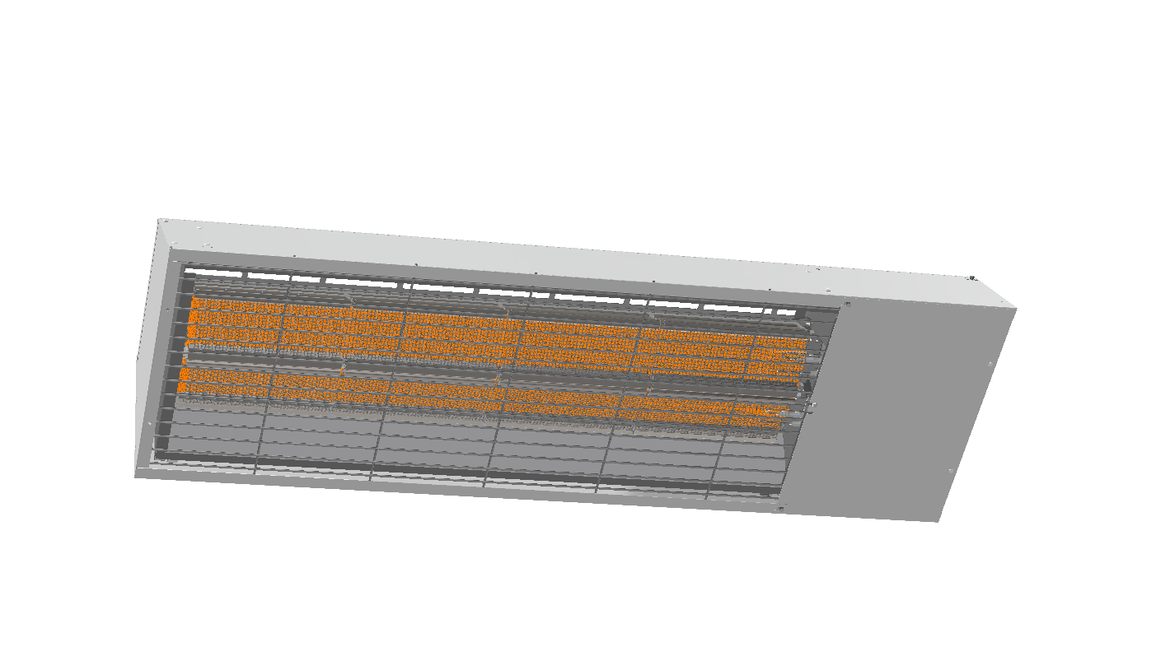

*Bottom view:*

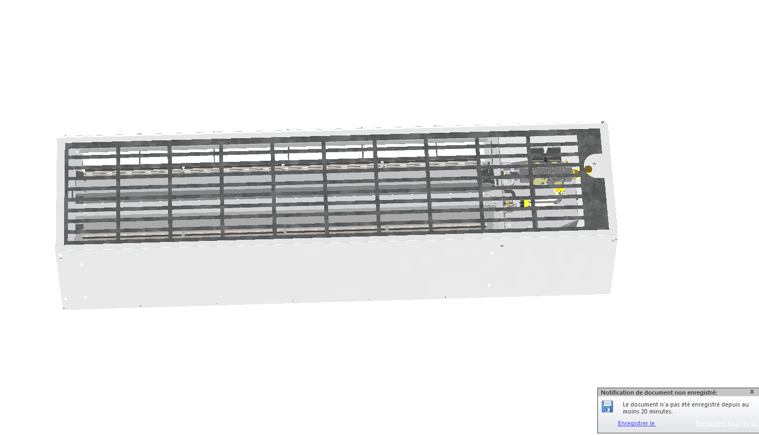

|  |  |  |  |
| --- | --- | --- | --- |
| **REP** | **Designation** | **Quantity** | **Remark** |
| 1 | Radiant panel SRII | 1 | Exactly the same as the standard model |
| 2 | Casing | 1 | White casing |
| 3 | Bottom grid | 1 |  |
| 4 | Top grid | 1 |  |

* 1. Gas line

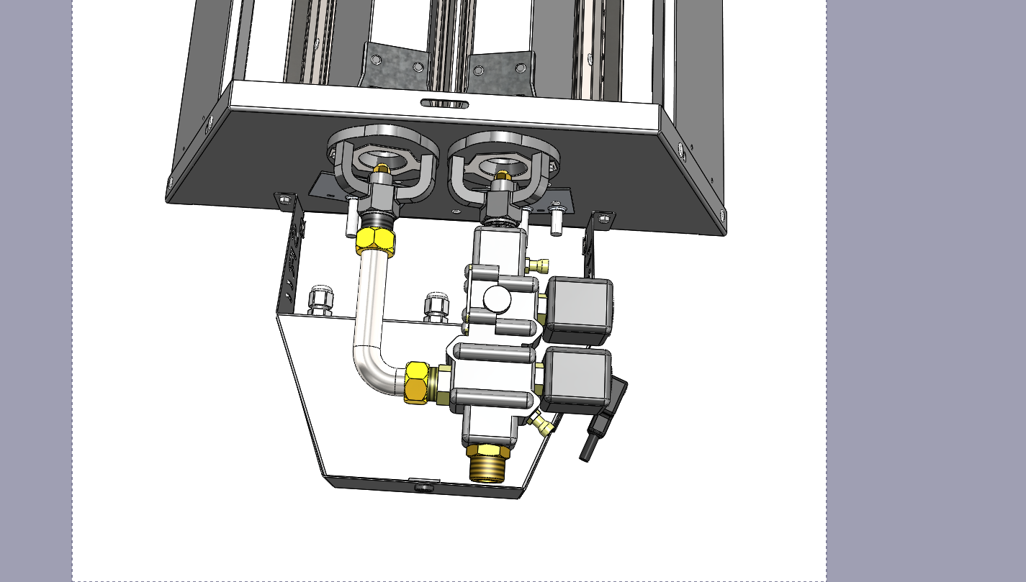

|  |  |  |  |
| --- | --- | --- | --- |
| **REP** | **Designation** | **Quantity** | ***Remark*** |
| 1 | Pressure intake | 2 |  |
| 2 | Electrovalve | 1 | Class A aluminium 1/2" socket  (displayed with ½" gas male connexion, from flexible piping kit) |
| 3 | Coil | 1  2 | SR II 21, 31, 41, 61, 81  SR II 42, 62, 82 |
| 4 | Converging ring | 1  2 | SR II 21, 31, 41  SR II 42, 62, 82, 61, 81 |
| 5 | Injector | 1  2 | SR II 21, 31, 41  SR II 42, 62, 82, 61, 81 |
| 6 | Diaphragm | 1  2 | SR II 21, 31, 41  SR II 42, 62, 82, 61, 81 |
| 7 | Elbow junction (1st stage) | 1 | SR II 42, 62, 82, 61, 81 only |
| 8 | Control and safety box | 1 |  |

* 1. Operating cycle



30 SECONDS

1. Technical data

|  |  |  |  |  |  |  |  |  |
| --- | --- | --- | --- | --- | --- | --- | --- | --- |
| **Model** | **Gas**  **type** | **Nominal feed pressure**  *(mbar)* | **Injector** | | **Diaphragm** | | **Nominal heat input**  *(kW LCV)* | **Gas flow rate**  *(m3/h at 15°C and 1013.25 hPa)*  *(kg/h for propane)* |
|  |  |  | nb | (mm) | nb | (mm) |  |
| **SR II 21** | G25 G20 | 25 20 | 1 1 | 1.90 1.85 | 1 1 | 26 32 | 6.2 | 0.76  0.66 |
| **SR II 31** | G25 G20 G31 | 25 20 37 | 1 1 1 | 2.40 2.35 1.55 | 1 1 1 | 28 32 32 | 9.75 | 1.20  1.03  0.76 |
| **SR II 41** | G25 G20 G31 | 25 20 37 | 1 1 1 | 2.80 2.70 1.75 | 1 - - | 32 - - | 12.8 | 1.57  1.36  1 |
| **SR II 61** | G25 G20 G31 | 25 20 37 | 2 2 2 | 2.40 2.35 1.55 | 2 2 2 | 28 32 32 | 19.5 | 2.40  2.06  1.52 |
| **SR II 81** | G25 G20 G31 | 25 20 37 | 2 2 2 | 2.80 2.70 1.80 | 2 - - | 32 - - | 25.7 | 3.16  2.72  2.00 |
| **SR II 42** | G25 G20 | 25 20 | 2 2 | 1.90 1.85 | 2 2 | 26 32 | 12.4 | 1.52  1.31 |
| **SR II 62** | G25 G20 G31 | 25 20 37 | 2 2 2 | 2.40 2.35 1.55 | 2 2 2 | 28 32 32 | 19.5 | 2.40  2.06  1.52 |
| **SR II 82** | G25 G20 G31 | 25 20 37 | 2 2 2 | 2.80 2.70 1.80 | 2 - - | 32 - - | 25.7 | 3.16  2.72  2.00 |

|  |  |
| --- | --- |
| **Gas connection** | 1/2‘’ - female cylinder |
| **Electrical connection** | 230V 1N ~ 50Hz |
| **Electric power** | 15 VA for SR II 21, 31, 41, 61, 81 models  30 VA for SR II 42, 62, 82 models |

1. Overall dimensions
   1. Standard models, with the ½" male connexion from the flexible piping kit

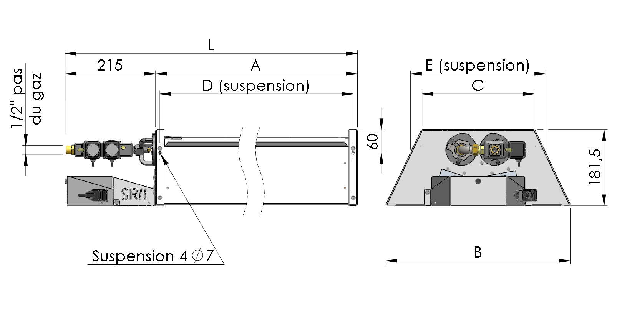

|  |  |  |  |  |  |  |  |
| --- | --- | --- | --- | --- | --- | --- | --- |
| MODEL | L mm | A mm | B mm | C mm | D mm | E mm | WEIGHT kg |
| SR II 21 | 813 | 598 | 315 | 150 | 578 | 200 | 11 |
| SR II 31 | 1082 | 867 | 847 | 13 |
| SR II 41 | 1349 | 1134 | 1114 | 15 |
| SR II 42 | 813 | 598 | 435 | 270 | 578 | 320 | 15 |
| SR II 61/62 | 1082 | 867 | 847 | 18,5 |
| SR II 81/82 | 1349 | 1134 | 1114 | 22 |

* 1. Cased models, displayed with the flexible piping kit

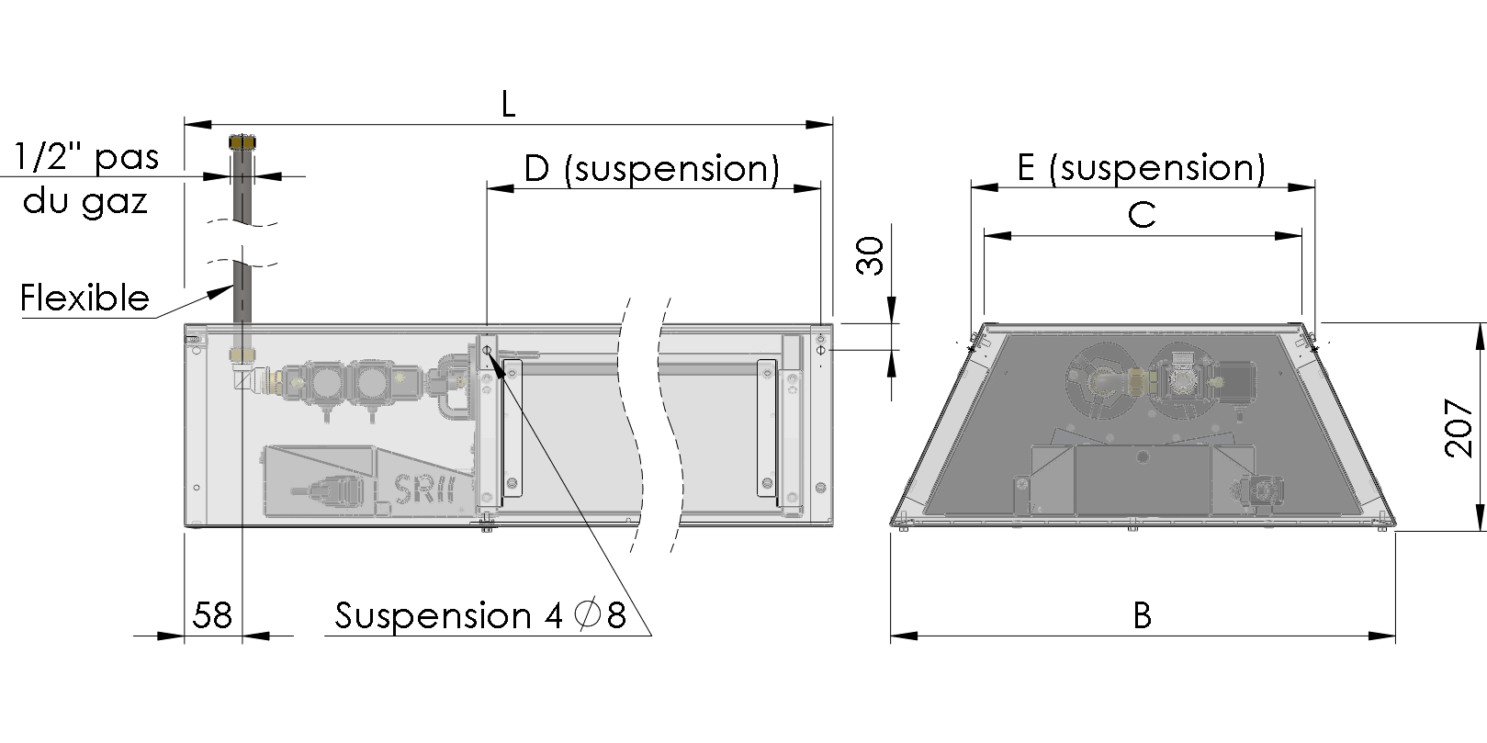

|  |  |  |  |  |  |  |
| --- | --- | --- | --- | --- | --- | --- |
| MODEL | L mm | B mm | C mm | D mm | E mm | WEIGHT kg |
| SR II 21 | 918 | 380 | 195 | 606 | 220 | 16 |
| SR II 31 | 1187 | 875 | 20 |
| SR II 41 | 1454 | 1142 | 23 |
| SR II 42 | 918 | 500 | 315 | 606 | 340 | 23 |
| SR II 61/62 | 1187 | 875 | 27 |
| SR II 81/82 | 1454 | 1142 | 32 |

1. Installation of the appliance

 Installation of gas appliances must be carried out by qualified personnel. It is determined by the premises volume and location characteristics, equipment vent or ventilation device which may be installed in those premises.

Delivery scope:

* 1 radiant panel
* 1 bag containing 4 hooks and 4 springs
* 1 square connector + cable for electric supply
* 1 technical instruction

Reception – Storage

The gas heating appliance is delivered on a wooden pallet, protected by a cardboard and plastic film. It is essential to check the delivered material status (even if the packaging is intact) and its compliance with the order.

In the event of damage or missing parts, report comments on the carrier's receipt as accurately as possible, the words "subject to unpacking" has no legal value, and then confirm the prejudice by letter within 48h to the carrier. The buyer is responsible to check the goods delivered, no appeal is possible if this procedure is not followed.

Store the material in a clean, dry place, protected from shock, vibration, temperature variations and room humidity less than 90 %.

Handling

Unpack the appliance using protective equipment as required. Handling must be performed by a person equipped with the proper equipment.

* 1. General rules

Radiant panels SRII can be installed directly into the premises to be heated.

However, this facility is subject to the national security rules depending on the fuel type used and the installation country. If in doubt, check with safety and inspection bodies.

Ventilation:

Premises receiving gas appliances should be provided with permanent ventilation in accordance with the applicable rules in the country of installation.

Gas connection:

Before installing the appliance, it is necessary to check that the local distribution conditions (gas type, pressure) are compatible with settings of the device to be installed.

** WARNING**

Minimum distance in relation to combustible materials:

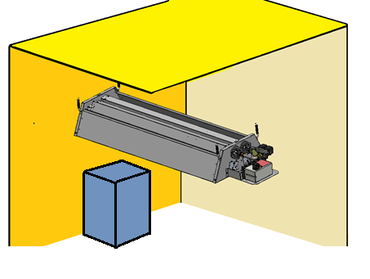 If the units are installed over a crane or any other appliances likely to stay at less than a meter of the unit, do contact the technical department of Solaronics Chauffage.

0.6 m

0.75 m

1.2 m

3 m minimum

0.6 m

* 1. Implantation

The power, number, height and position of the radiant panels SRII have to be adjusted accordingly.

* + 1. Recommended hanging heights

|  | **SRII21** | **SRII31** | **SRII41**  **SRII42** | **SRII61**  **SRII62** | **SRII81**  **SRII82** |
| --- | --- | --- | --- | --- | --- |
| Min. recommended hanging height | 4 m | 4 m | 5 m | 6 m | 7 m |
| Max. recommended hanging height | 5 m | 5 m | 6 m | 7 m | 9 m |

* + 1. Tilt

The radiant panel SRII must be set horizontally. However a slope from 2 to 3° is accepted if the gas valve is at the lowed position.

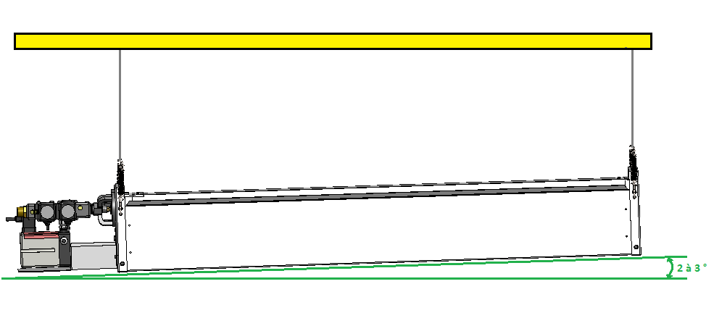

** WARNING**

If installed in a tilt position, a maximum tilt of 25° is recommended

For radiant panel SRII42, 62 and 82, it is imperative that the burner of the 1st stage is in top position. The burner of the 1st stage is located to the left when we look at side line gas.

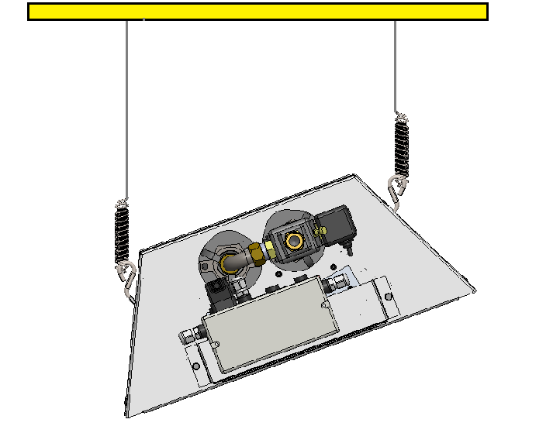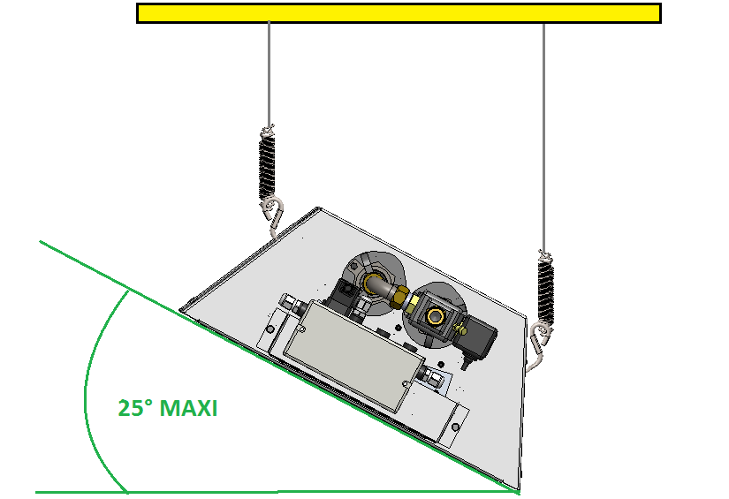

* + 1. Handling for hanging

Raise the device with a forklift truck, or a boom lift suited in sized and dimensions.

In every case be careful not to damage reflectors.

* + 1. Hanging

Before fixing devices, it is advisable to make sure of the resistance of the support.

Generally speaking, the suspensions must be flexible (chains, ropes or steel cables) and the tensions between hanging points must be distributed in a fair way. If the premise is equipped with an overhead crane and/or subjected to important vibrations the use of chains is strongly recommended.

The lengths of the suspensions shall not be lower than 0.9 m.

The SR II units are supplied with suspension springs, these must be used imperatively so as to avoid any vibration, or noises due to the possible presence of travelling cranes and which may damage the unit.

1st step:

- Check the support resistance

2nd step:

- Fix the device in 4 points

- Adjust the slope of the device

* + 1. Combustion products and ventilation of the premises

Combustion products are released into the surrounding atmosphere.

Although the operating of the SRII is particularly health-friendly, existing regulations impose rates of air renewal.

The EN13410 standard impose a rate of air renewal of 10 m3/h per kW heat input to which must be added air renewal for breathing laid down in Local Health Regulations.

|  |  |  |  |  |  |
| --- | --- | --- | --- | --- | --- |
| Model | SRII 21 | SRII 31 | SRII 41-42 | SRII 61-62 | SRII 81-82 |
| Air renewal (m3/h) | 70 | 100 | 130 | 200 | 260 |

* 1. Gas connection

Firstly, you should check that the device you have received is consistent with the distributed gas group. To do this, you should refer to the information given on the heater data plate.

The gas supply must match the heater output and be equipped with all safety and control devices provided by standards.

A detailed study will be carried out on duct diameters depending on the nature of gas flow and the ducts length. It should ensure that ducts pressure drop does not exceed 5% of the supply pressure. The gas connections must be performed in accordance with indoor installations requirements regardless the type of gas, by qualified personnel having the applicable approvals.

Before commissioning, ensure that the gas line is tight and clean all residues caused by the work

** WARNING**

The pipes of gas supply, the regulator or the flexible hose have to be installed on no account over the device. A minimal distance of 75 cm must be respected.

** WARNING**

Before opening the gas network, check the valve tightness to the appliance heating unit

The connecting of the device to the gas network by a flexible hose is also compulsory for:

* facilitate the assembly / dismantling,
* avoid the transmission of mechanical constraints.

The assembly of the flexible hose is made by tightening in the hand follow-up of a tightening of a quarter of turn maximum with a key.

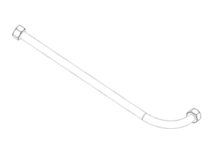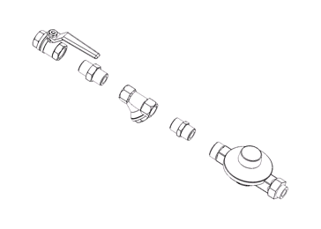

**

**(1)** Quarter turn gas valve - **(2)** gas filter - **(3)** gas regulator

**(F)** Flexible - **(4)** 1/2" Male-Male connector

*Example of gas connection*

1. Temperature control - electrical connection
   1. Temperature control

The regulation of temperature is made in an on/off mode by switching the power supply of devices.

The temperature of comfort of the radiant devices is measured by a probe with black ball, which determines the resultant temperature between the air temperature and the radiation emitted by devices.

Solaronics Chauffage developed a range of specific regulation.

These equipments are delivered cabled and with their electric plan

We shall plan:

- 1 probe with black ball by zone

- 1 shielded cable 2 x 1 ² by zone to connect the probe with the regulation

Besides the respect of instructions during the installation of a set of regulation, it is advisable of:

- Position the probe at the level of man in a zone not subjected to drafts and receiving a radiation in a homogeneous way.

- Fix the probe on the heat insulator material of the wall, when this support is held. The wall emits a cold radiation, opposing the good measure of the probe

* 1. Electrical connections
     1. Connections
* Check the power supply: 230 Volts (+10%,-15%) 50 Hz, no neutral impedance (i.e. 0V between neutral and earth). In case of neutral impedance, an isolation transformer is compulsory.
* **Number of conductors**

Power supply for each circuit shall include:

- two active conductors and one protection conductor of identical sections for the SR II 21, 31, 41, 61, 81,

- three active conductors and one protection conductor of identical sections for the SR II 42, 62 and 82.

* **Colour of conductors**

Phase: any colours except white-grey, light blue, green, yellow, and two-coloured green-yellow.

Neutral: light blue.

Protection (earth): two-coloured green-yellow.

* **Electrical connection**

The SR II must be connected to the mains via a connector (supplied with the unit). It is compulsory to connect the connector according the hereafter drawing.

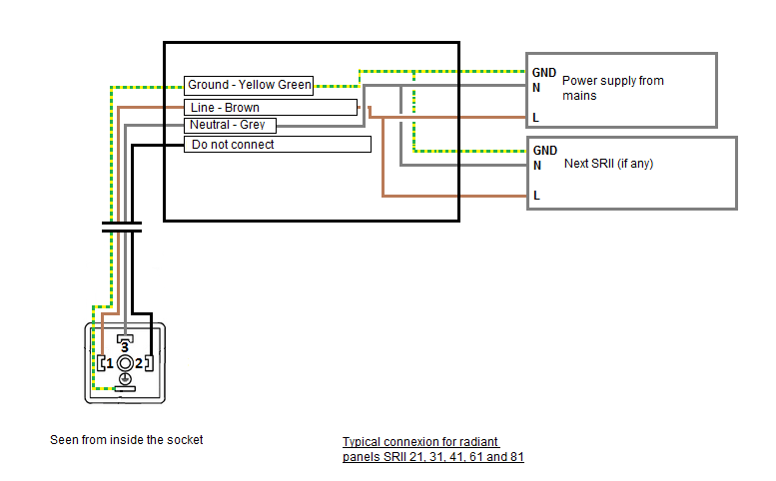

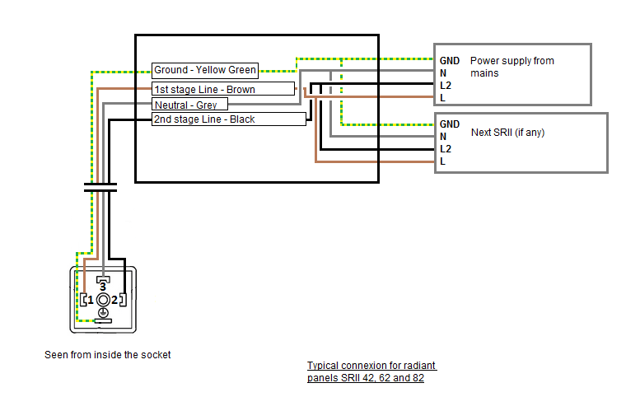

** WARNING**

1) Taking into account the maximum consumption upon lighting up, a section of 1.5 mm² per conductor will be enough to supply 30 units.

2) Cables shall not go over the unit. If they have to travel alongside it, the distance shall never be less than 0.50m.

**3) Wirings to the units must be carried out with a flex cable of 0.75 mm² conductors**.

* **Remote fault signal (in option)**

SRII radiant panels are available with a remote fault relay (in option). This option enables, thanks to a SPDT, to signal a fault on a unit to the control system information.

The wiring of this option is done directly to the pins of the safety and control board of the unit (see Scheme 7.2.2).

* + 1. Wiring diagram of the control and safety box

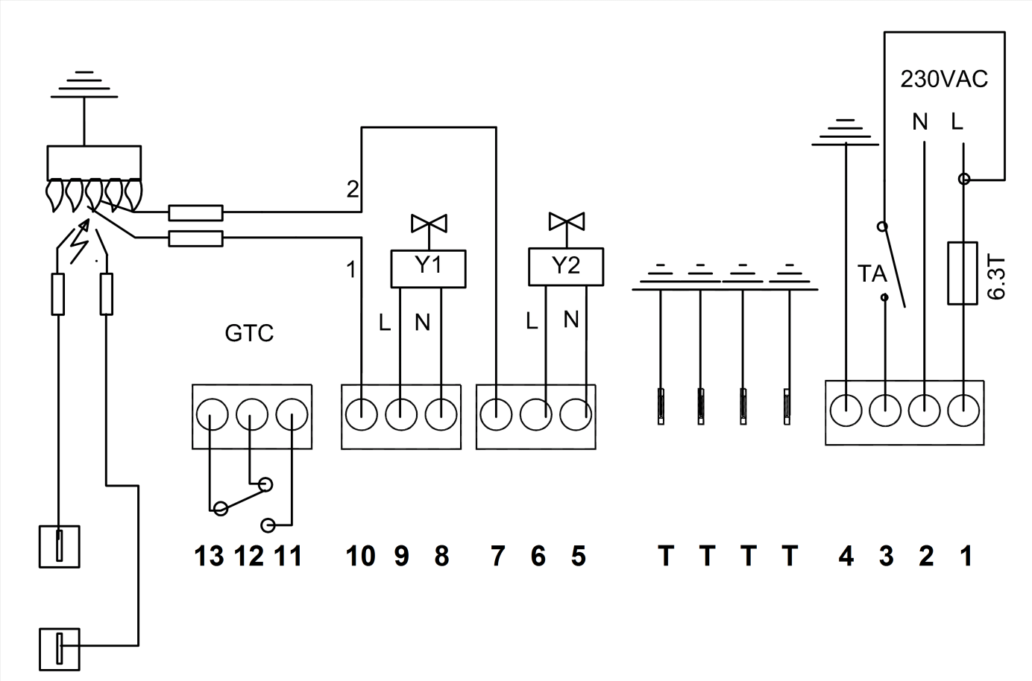

|  |  |  |  |
| --- | --- | --- | --- |
| **Terminal** | **Description** | **Colour of wires**  **inside** | **Models** |
| 1 | Power supply : line  (first stage) | Brown | All |
| 2 | Power supply : neutral | Blue | All |
| 3 | Power supply : line  (second stage) | Red | SRII 42, 62 and 82 |
| 4 | Power supply : earth | Yellow/green | SRII 42, 62 and 82 |
| T | Earth terminal | Yellow/green | All |
| 5 | Electrovalve - 2nd stage - Neutral | Blue | SRII 42, 62 and 82 |
| 6 | Electrovalve - 2nd stage –  Line | Brown | SRII 42, 62 and 82 |
| 7 | Ionization electrode –  2nd stage | Red | SRII 42, 61, 62, 81 and 82 |
| 8 | Electrovalve - 1st stage –  Neutral | Blue | All |
| 9 | Electrovalve - 1st stage –  Line | Brown | All |
| 10 | Ionization electrode – 1st stage | Red | All |
| 11 | Remote fault : NO | User | Optional |
| 12 | Remote fault : NC | User | Optional |
| 13 | Remote fault : C | User | Optional |
| HV Terminal | Sparking electrode – 1st and 2nd stages | Black | SRII 21, 31 and 41 (1 electrode)  SRII 42, 61, 62, 81 and 82 (2 electrodes) |

1. Commissioning
   1. Start-up

1- Before commissioning and turning on the heater, check that all connections have been carried out as defined above:

* § "Gas connection"
* § "Electrical connection"

Check also:

* Distances around the heater are respected
* That all electrical components connections are made
* That earth connection is effective

2- Check the supply voltage at the heater terminals. The voltage value must be between 210 V and 230 V (AC).

3- Check that the gas type and supply pressure comply with the appliance. Check that the general gas valve is open, purge the gas line. Open valve upstream of each appliance.

4– Check on the temperature controller that no sensor is faulty

5- Switch on the heaters.

On the control, increase the set point temperature to a value higher by more than 1 °C to the room temperature, then switch to automatic mode

6- Set the controller (refer to the its instructions)

1. TROUBLESHOOTIONG
   1. Troubleshooting

In case of problem, always check that prerequisites in the smooth running of unit ("Starting up" section) are performed.

If the control box is in safety mode, reset it

** WARNING**

All electrical or mechanical interventions should be made when the power is turned off and the gas supply closed.

| **Symptoms** | | **Possible causes** | | **Remedy** | |
| --- | --- | --- | --- | --- | --- |
| **Lighting and flame control device** | **Burner** |  | |  | |
|  | Does not light up upon the first attempt | | - Gas shut-off valve shut  - Gas lines inadequately bled | - Turn valve on  - Bled the gas line | | |
| The light-up cycle proceeds normally with HV sparks between light-up electrode and earth | Does not light up after several attempts | | - Filter ahead the reducer clogged  - Injector clogged or partially clogged  - Ill-suited injector  - Gap between light-up electrode is too wide  - Electrovalve jammed in ‘off’ position | - Clean the filter  - Clean the injector  - Replace injector  - Adjust gap  - Replace the electrovalve | | |
| The light-up cycle proceeds normally with HV sparks between light-up electrode and earth | The burner lights up but goes out within 4 seconds upon light-up | | - Ill-suited injector  - Ionisation electrode badly positioned in relation to burner or earth  - Poor earthing on safety box  - The safety box is defective (ionisation control is too slack)  - Phase-neutral inversion  - Neutral impedance | - Replace the injector  - Reposition the electrode  - Clean point contact  - Replace the control box  - Connect properly  - Fit in an isolation transformer |
| No high tension sparks between The light-up cycle p light-up electrode and earth |  | | - No electric power  - Melted fuse wire  - Light-up electrode widen  - Oil the light-up electrode  - Electrode ceramic cracked (leaking of sparks or burner or box)-  - Poor connection to HV wire or poor earth  - Light-up box defect | -Check arrival of sector  - Replace the fuse wire when cause is found  - Adjust the separation  - Clean with a solvent  - Change electrode  - Redo the connections correctly  - Change this |

** WARNING**

Warning, only genuine manufacturer parts ensure product and people safety. The use of parts other than genuine ones invokes the responsibility of the individual and will void the product warranty.

* 1. Spare parts

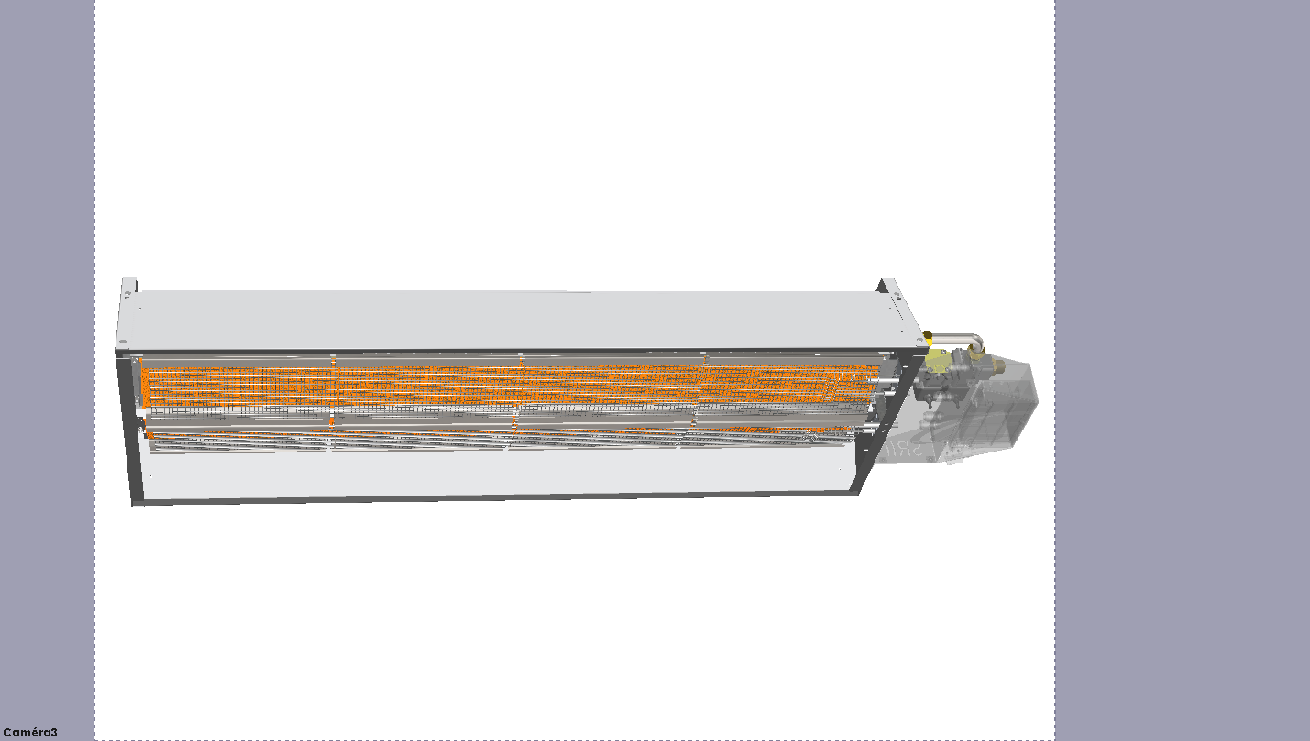

| **Nº** | **Designation** | **Code** |
| --- | --- | --- |
| **1** | Control and safety device – 1 stage (SR II 21, 31 and 41 models) without relay | 9424170 |
| Control and safety device – 1 stage (SR II 21, 31 and 41 models) **with relay** | 9424171 |
| Control and safety device – 1 stage SR II 61 and 81 models) with relay | 9424174 |
| Control and safety device – 2 stages (SR II 42, 62 and 82 models) without relay | 9424172 |
| Control and safety device – 2 stages (SR II 42, 62 and 82 models) **with relay** | 9424173 |
| **2** | Valve coil | 9421364 |
| **3** | Gas valve – 1 stage ( SR II 21, 31 and 41 models) | 9421371 |
| Gas valve – 1 stage (SR II 61 and 81 models) | 9421376 |
| Gas valve – 2 stages (SR II 42, 62 and 82 models) | 9421375 |
| **4** | Ionisation and ignition electrodes | 7223049 |
| **5** | 4 tiles burner kit (SR II 21 and 42 models) | 7220300 |
| 6 tiles burner kit (SR II 31, 61 and 62 models) | 7220302 |
| 8 tiles burner kit (SR II 41, 81 and 82 models) | 7220304 |
| 4 tiles burner kit – Place of worship (SR II 21 and 42 models) | 7220306 |
| 6 tiles burner kit - Place of worship (SR II 31, 61 and 62 models) | 7220307 |
| 8 tiles burner kit - Place of worship (SR II 41, 81 and 82 models) | 7220308 |

** WARNING**

Do contact SOLARONICS CHAUFFAGE before replacing any other parts.

1. Maintenance

A proper and regular maintenance, at least once a year, determine an efficient and effective functioning, a minimum gas consumption and an important longevity.

** WARNING**

The gas device must be maintained cold and with electric power cut

These works can be performed by a qualified technician only

* 1. Sequence of operations

- Inspect radiant surface

- Turn off electric and gas supplies

- Clean gas filter

- Clean the injector, the mixer and the electrodes

- Reassemble and reconnect electric and gas supplies

- Check gas circuit for leaks

- Check light up and flame control device.

* 1. Maintenance operations
     1. Cased models: Removal of the casing

Unscrew a little bit the 5 hexagon head screws (2) (wrench of size 8) so as to take off the removal parts of the casing (1):

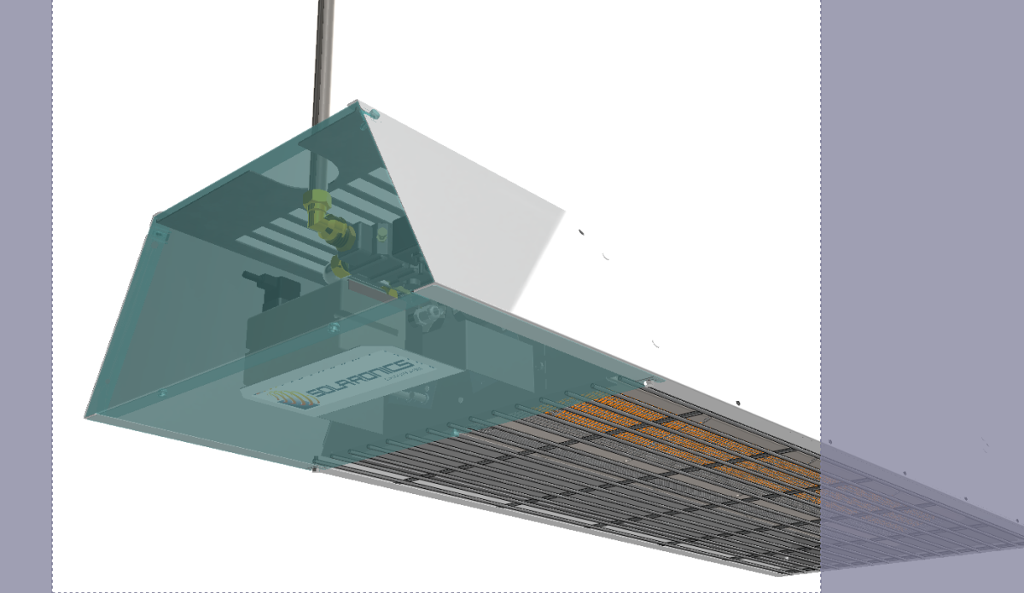

Access to the burner(s) by sliding the below grid.

* + 1. Inspection of radiant surface

In case a wafer leaks or shows cracks, replace the burner.

* + 1. Electrodes

A single screw holds the electrode support plate.

Take them down, clean them (use a metal brush), check the gap between light up electrodes, re-install and check position adjustment;

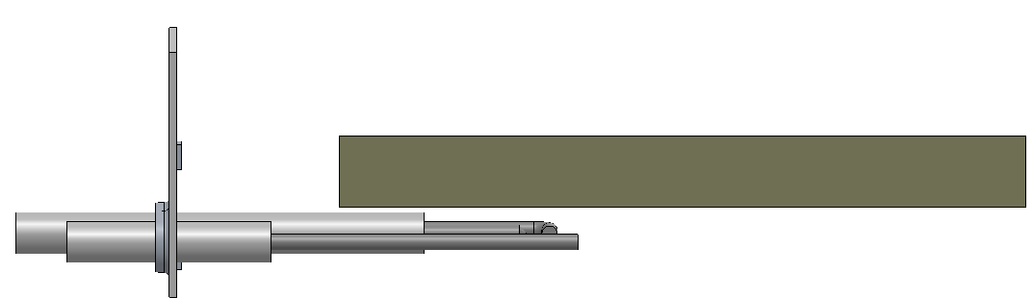

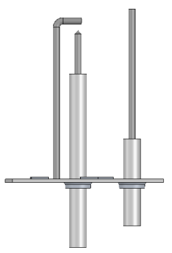

3.5 mm +/- 0.5

5 mm +/- 0.5

* + 1. Cleaning of the mixer and injector

- Unlock the screws (marking 1)

- Unblock and release the ring (marking 2)

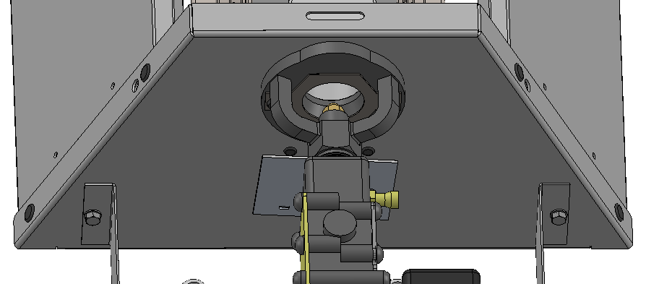

- Unscrew the injector (marking 3)

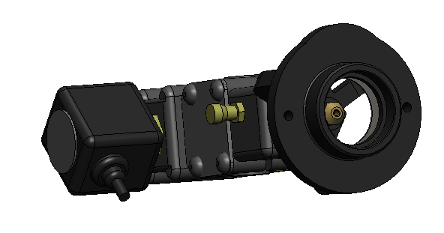

Soak the injector in solvent and blow it dry with compressed air. Do not use metal wire.

- Clean the mixer (marking 4)

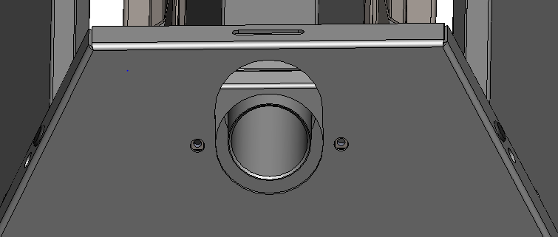

 See that the injector is properly sealed inside its holder.

Do not use joint compounds or PTFE products.

1. Warranty

Your appliance has a contractual guaranty against any manufacturing defect.

Solaronics Chauffage is not responsible for improper use of the device, failure or insufficient maintenance, or improper installation of the appliance (it is your responsibility to ensure that it is carried out by a qualified professional).

In particular, Solaronics Chauffage will not be liable for any damage, loss or injury caused by improper installation that does not comply:

• with rules in force or imposed by the local authorities

• with national, or even local and specific rules governing the installation

• with our technical instructions, in particular, for maintenance of the devices

• with the good engineering practice

Solaronics Chauffage warranty is limited to replacement or repair of defective parts only by our services excluding labor costs, travel and transport.

Our warranty does not cover replacement or repair of damaged parts by normal wear and tear, misuse, unskilled third party interventions, defect or failure in monitoring or maintenance, non-compliant power supply or use of an inappropriate fuel or of poor quality.

Subsets, such as motors, pumps, electric valves, etc ... are only guaranteed if they have never been removed.

Rights established by the European Directive 1999/44/CEE remain valid.

1. Information

|  |  |  |  |  |  |  |  |  |  |  |  |  |  |  |  |  |  |
| --- | --- | --- | --- | --- | --- | --- | --- | --- | --- | --- | --- | --- | --- | --- | --- | --- | --- |
| Model identifier :  **SRII 21** | | | | | | | | | | | | | | | | | |
| Type of heating : **Luminous** | | | | | | | | | | | | | | | | | |
| **Fuel** | | | | | **Fuel** | | |  | |  | Space heating emissions(*) | | | | | | |
| NOx | | | | | | |
| Select fuel type | | | | | **Gaseous** | | | **G20/G25** | |  | **18 mg/kWh input(GCV)** | | | | | | |
|  | | | | |  | | |  | |  |  | | | | | | |
| **Characteristics when operating with the preferred fuel only** | | | | | | | | | | | | | | | | | |
| Item | Symbol | | | Value | | Unit |  | | Item | | | Symbol | | Value | | Unit | |
| **Heat output** |  | | |  | |  |  | | **Useful efficiency (GCV) – Tube local space heaters only (**)** | | | | | | | | |
| Nominal heat output | Pnom | | | 5,9 | | kW |  | | Useful efficiency at nominal heat output | | | | Ƞth, nom | | 85,6 | | % |
| Minimum heat output | Pmin | | | (N.A) | | kW |  | | Useful efficiency at minimum heat output | | | | Ƞth,min | | (N.A) | | % |
| Minimum heat output ( as percentage of nominal heat output) | **..** | | | (N.A) | | **%** |  | |  | | | |  | |  | |  |
| Nominal tube system heat output ( if applicable) | P système | | | (N.A) | | kW |  | |  | | | |  | |  | |  |
| Nominal tube segment heat output (if applicable) | P heater | | | (N.A) | | kW |  | | Useful efficiency of tube segment at minimum heat output ( if applicable) | | | | Ƞi | | (N.A) | | % |
| (Repeat for multiple segment, if applicable) | .. | | | (N.A) | | kW |  | | (repeat for multiple segments, if applicable) | | | | .. | | (N.A) | | % |
| Number of identical tube segments | n | | | (N.A) | | (-) |  | |  | | | |  | |  | |  |
| **Radiant factor** |  | | |  | |  |  | | **Envelope losses** | | | |  | |  | |  |
| Radiant factor at nominal heat output | RFnom | | | 67 | | (-) |  | | Envelope insulation class | | | | U | | (N.A) | | W/  (m²K) |
| Radiant factor at minimum heat output | RFmin | | | (N.A) | | (-) |  | | Envelope loss factor | | | | F env | | (N.A) | | % |
| Radiant factor of tube segment at nominal heat output | RFi | | | (N.A) | | (-) |  | | Heat generator to be installed outside the heated area | | | |  | | No | |  |
| (repeat for multiple segments, if applicable) | .. | | |  | |  |  | |  | | | |  | |  | |  |
|  |  | | |  | |  |  | |  | | | |  | |  | |  |
| **Auxiliary electricity consumption** | | | | | | |  | | **Heat output control type ( select one)** | | | | | | | | |
| At nominal heat output | el max | | | 0,015 | | kW |  | | Single stage | | | | | | yes | |  |
| At minimum heat output | el min | | | 0,015 | | kW |  | | Two stage | | | | | | no | |  |
| In standby mode | el SB | | | (N.A) | | kW |  | | Modulating | | | | | | no | |  |
|  | | | | | | |  | |  | | | | | | | | |
| **Permanent pilot flame power requirement** | | | | | | |  | |  | | | | | | | | |
| Pilot flame power requirement (if applicable) | | P pilot | (N.A) | | | kW |  | |  | | | | | | | | |
| Contact details | | SOLARONICS Chauffage SA.  78 rue du Kemmel - B.P. 30173 – 59428 ARMENTIERES CEDEX France | | | | | | | | | | | | | | | |
| (*) NOx = nitrogen oxides  (**) For luminous local space heaters the weighted thermal efficiency is by default 85.6% | | | | | | | | | | | | | | | | | |

|  |  |  |  |  |  |  |  |  |  |  |  |  |  |  |  |  |  |
| --- | --- | --- | --- | --- | --- | --- | --- | --- | --- | --- | --- | --- | --- | --- | --- | --- | --- |
| Model identifier :  **SRII 31** | | | | | | | | | | | | | | | | | |
| Type of heating : **Luminous** | | | | | | | | | | | | | | | | | |
| **Fuel** | | | | | **Fuel** | |  | | |  | Space heating emissions(*) | | | | | | |
| NOx | | | | | | |
| Select fuel type | | | | | **Gaseous** | | **G20/G25/G31** | | |  | **18 mg/kWh input(GCV)** | | | | | | |
|  | | | | |  | |  | | |  |  | | | | | | |
| **Characteristics when operating with the preferred fuel only** | | | | | | | | | | | | | | | | | |
| Item | Symbol | | | Value | | Unit | |  | Item | | | Symbol | | Value | | Unit | |
| **Heat output** |  | | |  | |  | |  | **Useful efficiency (GCV) – Tube local space heaters only (**)** | | | | | | | | |
| Nominal heat output | Pnom | | | 9,3 | | kW | |  | Useful efficiency at nominal heat output | | | | Ƞth, nom | | 85,6 | | % |
| Minimum heat output | Pmin | | | (N.A) | | kW | |  | Useful efficiency at minimum heat output | | | | Ƞth,min | | (N.A) | | % |
| Minimum heat output ( as percentage of nominal heat output) | **..** | | | (N.A) | | **%** | |  |  | | | |  | |  | |  |
| Nominal tube system heat output ( if applicable) | P système | | | (N.A) | | kW | |  |  | | | |  | |  | |  |
| Nominal tube segment heat output (if applicable) | P heater | | | (N.A) | | kW | |  | Useful efficiency of tube segment at minimum heat output ( if applicable) | | | | Ƞi | | (N.A) | | % |
| (Repeat for multiple segment , if applicable) | .. | | | (N.A) | | kW | |  | (repeat for multiple segments, if applicable) | | | | .. | | (N.A) | | % |
| Number of identical tube segments | n | | | (N.A) | | (-) | |  |  | | | |  | |  | |  |
| **Radiant factor** |  | | |  | |  | |  | **Envelope losses** | | | |  | |  | |  |
| Radiant factor at nominal heat output | RFnom | | | 67 | | (-) | |  | Envelope insulation class | | | | U | | (N.A) | | W/  (m²K) |
| Radiant factor at minimum heat output | RFmin | | | (N.A) | | (-) | |  | Envelope loss factor | | | | F env | | (N.A) | | % |
| Radiant factor of tube segment at nominal heat output | RFi | | | (N.A) | | (-) | |  | Heat generator to be installed outside the heated area | | | |  | | No | |  |
| (repeat for multiple segments, if applicable) | .. | | |  | |  | |  |  | | | |  | |  | |  |
|  |  | | |  | |  | |  |  | | | |  | |  | |  |
| **Auxiliary electricity consumption** | | | | | | | |  | **Heat output control type ( select one)** | | | | | | | | |
| At nominal heat output | el max | | | 0,015 | | kW | |  | Single stage | | | | | | yes | |  |
| At minimum heat output | el min | | | 0,015 | | kW | |  | Two stage | | | | | | no | |  |
| In standby mode | el SB | | | (N.A) | | kW | |  | Modulating | | | | | | no | |  |
|  | | | | | | | |  |  | | | | | | | | |
| **Permanent pilot flame power requirement** | | | | | | | |  |  | | | | | | | | |
| Pilot flame power requirement (if applicable) | | P pilot | (N.A) | | | kW | |  |  | | | | | | | | |
| Contact details | | SOLARONICS Chauffage SA.  78 rue du Kemmel - B.P. 30173 – 59428 ARMENTIERES CEDEX France | | | | | | | | | | | | | | | |
| (*) NOx = nitrogen oxides  (**) For luminous local space heaters the weighted thermal efficiency is by default 85.6% | | | | | | | | | | | | | | | | | |

|  |  |  |  |  |  |  |  |  |  |  |  |  |  |  |  |  |  |
| --- | --- | --- | --- | --- | --- | --- | --- | --- | --- | --- | --- | --- | --- | --- | --- | --- | --- |
| Model identifier :  **SRII 41** | | | | | | | | | | | | | | | | | |
| Type of heating : **Luminous** | | | | | | | | | | | | | | | | | |
| **Fuel** | | | | | **Fuel** | |  | | |  | Space heating emissions(*) | | | | | | |
| NOx | | | | | | |
| Select fuel type | | | | | **Gaseous** | | **G20/G25/G31** | | |  | **18 mg/kWh input(GCV)** | | | | | | |
|  | | | | |  | |  | | |  |  | | | | | | |
| **Characteristics when operating with the preferred fuel only** | | | | | | | | | | | | | | | | | |
| Item | Symbol | | | Value | | Unit | |  | Item | | | Symbol | | Value | | Unit | |
| **Heat output** |  | | |  | |  | |  | **Useful efficiency (GCV) – Tube local space heaters only (**)** | | | | | | | | |
| Nominal heat output | Pnom | | | 12,2 | | kW | |  | Useful efficiency at nominal heat output | | | | Ƞth, nom | | 85,6 | | % |
| Minimum heat output | Pmin | | | (N.A) | | kW | |  | Useful efficiency at minimum heat output | | | | Ƞth,min | | (N.A) | | % |
| Minimum heat output ( as percentage of nominal heat output) | **..** | | | (N.A) | | **%** | |  |  | | | |  | |  | |  |
| Nominal tube system heat output ( if applicable) | P système | | | (N.A) | | kW | |  |  | | | |  | |  | |  |
| Nominal tube segment heat output (if applicable) | P heater | | | (N.A) | | kW | |  | Useful efficiency of tube segment at minimum heat output ( if applicable) | | | | Ƞi | | (N.A) | | % |
| (Repeat for multiple segment , if applicable) | .. | | | (N.A) | | kW | |  | (repeat for multiple segments, if applicable) | | | | .. | | (N.A) | | % |
| Number of identical tube segments | n | | | (N.A) | | (-) | |  |  | | | |  | |  | |  |
| **Radiant factor** |  | | |  | |  | |  | **Envelope losses** | | | |  | |  | |  |
| Radiant factor at nominal heat output | RFnom | | | 67 | | (-) | |  | Envelope insulation class | | | | U | | (N.A) | | W/  (m²K) |
| Radiant factor at minimum heat output | RFmin | | | (N.A) | | (-) | |  | Envelope loss factor | | | | F env | | (N.A) | | % |
| Radiant factor of tube segment at nominal heat output | RFi | | | (N.A) | | (-) | |  | Heat generator to be installed outside the heated area | | | |  | | No | |  |
| (repeat for multiple segments, if applicable) | .. | | |  | |  | |  |  | | | |  | |  | |  |
|  |  | | |  | |  | |  |  | | | |  | |  | |  |
| **Auxiliary electricity consumption** | | | | | | | |  | **Heat output control type ( select one)** | | | | | | | | |
| At nominal heat output | el max | | | 0,015 | | kW | |  | Single stage | | | | | | yes | |  |
| At minimum heat output | el min | | | 0,015 | | kW | |  | Two stage | | | | | | no | |  |
| In standby mode | el SB | | | (N.A) | | kW | |  | Modulating | | | | | | no | |  |
|  | | | | | | | |  |  | | | | | | | | |
| **Permanent pilot flame power requirement** | | | | | | | |  |  | | | | | | | | |
| Pilot flame power requirement (if applicable) | | P pilot | (N.A) | | | kW | |  |  | | | | | | | | |
| Contact details | | SOLARONICS Chauffage SA.  78 rue du Kemmel - B.P. 30173 – 59428 ARMENTIERES CEDEX France | | | | | | | | | | | | | | | |
| (*) NOx = nitrogen oxides  (**) For luminous local space heaters the weighted thermal efficiency is by default 85.6% | | | | | | | | | | | | | | | | | |

|  |  |  |  |  |  |  |  |  |  |  |  |  |  |  |  |  |  |
| --- | --- | --- | --- | --- | --- | --- | --- | --- | --- | --- | --- | --- | --- | --- | --- | --- | --- |
| Model identifier :  **SRII 42** | | | | | | | | | | | | | | | | | |
| Type of heating : **Luminous** | | | | | | | | | | | | | | | | | |
| **Fuel** | | | | | **Fuel** | |  | | |  | Space heating emissions(*) | | | | | | |
| NOx | | | | | | |
| Select fuel type | | | | | **Gaseous** | | **G20/G25/G31** | | |  | **18 mg/kWh input(GCV)** | | | | | | |
|  | | | | |  | |  | | |  |  | | | | | | |
| **Characteristics when operating with the preferred fuel only** | | | | | | | | | | | | | | | | | |
| Item | Symbol | | | Value | | Unit | |  | Item | | | Symbol | | Value | | Unit | |
| **Heat output** |  | | |  | |  | |  | **Useful efficiency (GCV) – Tube local space heaters only (**)** | | | | | | | | |
| Nominal heat output | Pnom | | | 11,8 | | kW | |  | Useful efficiency at nominal heat output | | | | Ƞth, nom | | 85,6 | | % |
| Minimum heat output | Pmin | | | 5,9 | | kW | |  | Useful efficiency at minimum heat output | | | | Ƞth,min | | 85,6 | | % |
| Minimum heat output ( as percentage of nominal heat output) | **..** | | | 50 | | **%** | |  |  | | | |  | |  | |  |
| Nominal tube system heat output ( if applicable) | P système | | | (N.A) | | kW | |  |  | | | |  | |  | |  |
| Nominal tube segment heat output (if applicable) | P heater | | | (N.A) | | kW | |  | Useful efficiency of tube segment at minimum heat output ( if applicable) | | | | Ƞi | | (N.A) | | % |
| (Repeat for multiple segment , if applicable) | .. | | | (N.A) | | kW | |  | (repeat for multiple segments, if applicable) | | | | .. | | (N.A) | | % |
| Number of identical tube segments | n | | | (N.A) | | (-) | |  |  | | | |  | |  | |  |
| **Radiant factor** |  | | |  | |  | |  | **Envelope losses** | | | |  | |  | |  |
| Radiant factor at nominal heat output | RFnom | | | 65 | | (-) | |  | Envelope insulation class | | | | U | | (N.A) | | W/  (m²K) |
| Radiant factor at minimum heat output | RFmin | | | 65 | | (-) | |  | Envelope loss factor | | | | F env | | (N.A) | | % |
| Radiant factor of tube segment at nominal heat output | RFi | | | (N.A) | | (-) | |  | Heat generator to be installed outside the heated area | | | |  | | No | |  |
| (repeat for multiple segments, if applicable) | .. | | |  | |  | |  |  | | | |  | |  | |  |
|  |  | | |  | |  | |  |  | | | |  | |  | |  |
| **Auxiliary electricity consumption** | | | | | | | |  | **Heat output control type ( select one)** | | | | | | | | |
| At nominal heat output | el max | | | 0,030 | | kW | |  | Single stage | | | | | | no | |  |
| At minimum heat output | el min | | | 0,015 | | kW | |  | Two stage | | | | | | yes | |  |
| In standby mode | el SB | | | (N.A) | | kW | |  | Modulating | | | | | | no | |  |
|  | | | | | | | |  |  | | | | | | | | |
| **Permanent pilot flame power requirement** | | | | | | | |  |  | | | | | | | | |
| Pilot flame power requirement (if applicable) | | P pilot | (N.A) | | | kW | |  |  | | | | | | | | |
| Contact details | | SOLARONICS Chauffage SA.  78 rue du Kemmel - B.P. 30173 – 59428 ARMENTIERES CEDEX France | | | | | | | | | | | | | | | |
| (*) NOx = nitrogen oxides  (**) For luminous local space heaters the weighted thermal efficiency is by default 85.6% | | | | | | | | | | | | | | | | | |

|  |  |  |  |  |  |  |  |  |  |  |  |  |  |  |  |  |  |
| --- | --- | --- | --- | --- | --- | --- | --- | --- | --- | --- | --- | --- | --- | --- | --- | --- | --- |
| Model identifier :  **SRII 61** | | | | | | | | | | | | | | | | | |
| Type of heating : **Luminous** | | | | | | | | | | | | | | | | | |
| **Fuel** | | | | | **Fuel** | |  | | |  | Space heating emissions(*) | | | | | | |
| NOx | | | | | | |
| Select fuel type | | | | | **Gaseous** | | **G20/G25/G31** | | |  | **18 mg/kWh input(GCV)** | | | | | | |
|  | | | | |  | |  | | |  |  | | | | | | |
| **Characteristics when operating with the preferred fuel only** | | | | | | | | | | | | | | | | | |
| Item | Symbol | | | Value | | Unit | |  | Item | | | Symbol | | Value | | Unit | |
| **Heat output** |  | | |  | |  | |  | **Useful efficiency (GCV) – Tube local space heaters only (**)** | | | | | | | | |
| Nominal heat output | Pnom | | | 18,5 | | kW | |  | Useful efficiency at nominal heat output | | | | Ƞth, nom | | 85,6 | | % |
| Minimum heat output | Pmin | | | (N.A) | | kW | |  | Useful efficiency at minimum heat output | | | | Ƞth,min | | (N.A) | | % |
| Minimum heat output ( as percentage of nominal heat output) | **..** | | | (N.A) | | **%** | |  |  | | | |  | |  | |  |
| Nominal tube system heat output ( if applicable) | P système | | | (N.A) | | kW | |  |  | | | |  | |  | |  |
| Nominal tube segment heat output (if applicable) | P heater | | | (N.A) | | kW | |  | Useful efficiency of tube segment at minimum heat output ( if applicable) | | | | Ƞi | | (N.A) | | % |
| (Repeat for multiple segment , if applicable) | .. | | | (N.A) | | kW | |  | (repeat for multiple segments, if applicable) | | | | .. | | (N.A) | | % |
| Number of identical tube segments | n | | | (N.A) | | (-) | |  |  | | | |  | |  | |  |
| **Radiant factor** |  | | |  | |  | |  | **Envelope losses** | | | |  | |  | |  |
| Radiant factor at nominal heat output | RFnom | | | 65 | | (-) | |  | Envelope insulation class | | | | U | | (N.A) | | W/  (m²K) |
| Radiant factor at minimum heat output | RFmin | | | (N.A) | | (-) | |  | Envelope loss factor | | | | F env | | (N.A) | | % |
| Radiant factor of tube segment at nominal heat output | RFi | | | (N.A) | | (-) | |  | Heat generator to be installed outside the heated area | | | |  | | No | |  |
| (repeat for multiple segments, if applicable) | .. | | |  | |  | |  |  | | | |  | |  | |  |
|  |  | | |  | |  | |  |  | | | |  | |  | |  |
| **Auxiliary electricity consumption** | | | | | | | |  | **Heat output control type ( select one)** | | | | | | | | |
| At nominal heat output | el max | | | 0,015 | | kW | |  | Single stage | | | | | | yes | |  |
| At minimum heat output | el min | | | 0,015 | | kW | |  | Two stage | | | | | | no | |  |
| In standby mode | el SB | | | (N.A) | | kW | |  | Modulating | | | | | | no | |  |
|  | | | | | | | |  |  | | | | | | | | |
| **Permanent pilot flame power requirement** | | | | | | | |  |  | | | | | | | | |
| Pilot flame power requirement (if applicable) | | P pilot | (N.A) | | | kW | |  |  | | | | | | | | |
| Contact details | | SOLARONICS Chauffage SA.  78 rue du Kemmel - B.P. 30173 – 59428 ARMENTIERES CEDEX France | | | | | | | | | | | | | | | |
| (*) NOx = nitrogen oxides  (**) For luminous local space heaters the weighted thermal efficiency is by default 85.6% | | | | | | | | | | | | | | | | | |

|  |  |  |  |  |  |  |  |  |  |  |  |  |  |  |  |  |  |
| --- | --- | --- | --- | --- | --- | --- | --- | --- | --- | --- | --- | --- | --- | --- | --- | --- | --- |
| Model identifier :  **SRII 62** | | | | | | | | | | | | | | | | | |
| Type of heating : **Luminous** | | | | | | | | | | | | | | | | | |
| **Fuel** | | | | | **Fuel** | |  | | |  | Space heating emissions(*) | | | | | | |
| NOx | | | | | | |
| Select fuel type | | | | | **Gaseous** | | **G20/G25/G31** | | |  | **18 mg/kWh input(GCV)** | | | | | | |
|  | | | | |  | |  | | |  |  | | | | | | |
| **Characteristics when operating with the preferred fuel only** | | | | | | | | | | | | | | | | | |
| Item | Symbol | | | Value | | Unit | |  | Item | | | Symbol | | Value | | Unit | |
| **Heat output** |  | | |  | |  | |  | **Useful efficiency (GCV) – Tube local space heaters only (**)** | | | | | | | | |
| Nominal heat output | Pnom | | | 18,5 | | kW | |  | Useful efficiency at nominal heat output | | | | Ƞth, nom | | 85,6 | | % |
| Minimum heat output | Pmin | | | 9,3 | | kW | |  | Useful efficiency at minimum heat output | | | | Ƞth,min | | 85,6 | | % |
| Minimum heat output ( as percentage of nominal heat output) | **..** | | | 50 | | **%** | |  |  | | | |  | |  | |  |
| Nominal tube system heat output ( if applicable) | P système | | | (N.A) | | kW | |  |  | | | |  | |  | |  |
| Nominal tube segment heat output (if applicable) | P heater | | | (N.A) | | kW | |  | Useful efficiency of tube segment at minimum heat output ( if applicable) | | | | Ƞi | | (N.A) | | % |
| (Repeat for multiple segment , if applicable) | .. | | | (N.A) | | kW | |  | (repeat for multiple segments, if applicable) | | | | .. | | (N.A) | | % |
| Number of identical tube segments | n | | | (N.A) | | (-) | |  |  | | | |  | |  | |  |
| **Radiant factor** |  | | |  | |  | |  | **Envelope losses** | | | |  | |  | |  |
| Radiant factor at nominal heat output | RFnom | | | 65 | | (-) | |  | Envelope insulation class | | | | U | | (N.A) | | W/  (m²K) |
| Radiant factor at minimum heat output | RFmin | | | 65 | | (-) | |  | Envelope loss factor | | | | F env | | (N.A) | | % |
| Radiant factor of tube segment at nominal heat output | RFi | | | (N.A) | | (-) | |  | Heat generator to be installed outside the heated area | | | |  | | No | |  |
| (repeat for multiple segments, if applicable) | .. | | |  | |  | |  |  | | | |  | |  | |  |
|  |  | | |  | |  | |  |  | | | |  | |  | |  |
| **Auxiliary electricity consumption** | | | | | | | |  | **Heat output control type ( select one)** | | | | | | | | |
| At nominal heat output | el max | | | 0,030 | | kW | |  | Single stage | | | | | | no | |  |
| At minimum heat output | el min | | | 0,015 | | kW | |  | Two stage | | | | | | yes | |  |
| In standby mode | el SB | | | (N.A) | | kW | |  | Modulating | | | | | | no | |  |
|  | | | | | | | |  |  | | | | | | | | |
| **Permanent pilot flame power requirement** | | | | | | | |  |  | | | | | | | | |
| Pilot flame power requirement (if applicable) | | P pilot | (N.A) | | | kW | |  |  | | | | | | | | |
| Contact details | | SOLARONICS Chauffage SA.  78 rue du Kemmel - B.P. 30173 – 59428 ARMENTIERES CEDEX France | | | | | | | | | | | | | | | |
| (*) NOx = nitrogen oxides  (**) For luminous local space heaters the weighted thermal efficiency is by default 85.6% | | | | | | | | | | | | | | | | | |

|  |  |  |  |  |  |  |  |  |  |  |  |  |  |  |  |  |  |
| --- | --- | --- | --- | --- | --- | --- | --- | --- | --- | --- | --- | --- | --- | --- | --- | --- | --- |
| Model identifier :  **SRII 81** | | | | | | | | | | | | | | | | | |
| Type of heating : **Luminous** | | | | | | | | | | | | | | | | | |
| **Fuel** | | | | | **Fuel** | |  | | |  | Space heating emissions(*) | | | | | | |
| NOx | | | | | | |
| Select fuel type | | | | | **Gaseous** | | **G20/G25/G31** | | |  | **18 mg/kWh input(GCV)** | | | | | | |
|  | | | | |  | |  | | |  |  | | | | | | |
| **Characteristics when operating with the preferred fuel only** | | | | | | | | | | | | | | | | | |
| Item | Symbol | | | Value | | Unit | |  | Item | | | Symbol | | Value | | Unit | |
| **Heat output** |  | | |  | |  | |  | **Useful efficiency (GCV) – Tube local space heaters only (**)** | | | | | | | | |
| Nominal heat output | Pnom | | | 24,4 | | kW | |  | Useful efficiency at nominal heat output | | | | Ƞth, nom | | 85,6 | | % |
| Minimum heat output | Pmin | | | (N.A) | | kW | |  | Useful efficiency at minimum heat output | | | | Ƞth,min | | (N.A) | | % |
| Minimum heat output ( as percentage of nominal heat output) | **..** | | | (N.A) | | **%** | |  |  | | | |  | |  | |  |
| Nominal tube system heat output ( if applicable) | P système | | | (N.A) | | kW | |  |  | | | |  | |  | |  |
| Nominal tube segment heat output (if applicable) | P heater | | | (N.A) | | kW | |  | Useful efficiency of tube segment at minimum heat output ( if applicable) | | | | Ƞi | | (N.A) | | % |
| (Repeat for multiple segment , if applicable) | .. | | | (N.A) | | kW | |  | (repeat for multiple segments, if applicable) | | | | .. | | (N.A) | | % |
| Number of identical tube segments | n | | | (N.A) | | (-) | |  |  | | | |  | |  | |  |
| **Radiant factor** |  | | |  | |  | |  | **Envelope losses** | | | |  | |  | |  |
| Radiant factor at nominal heat output | RFnom | | | 65 | | (-) | |  | Envelope insulation class | | | | U | | (N.A) | | W/  (m²K) |
| Radiant factor at minimum heat output | RFmin | | | (N.A) | | (-) | |  | Envelope loss factor | | | | F env | | (N.A) | | % |
| Radiant factor of tube segment at nominal heat output | RFi | | | (N.A) | | (-) | |  | Heat generator to be installed outside the heated area | | | |  | | No | |  |
| (repeat for multiple segments, if applicable) | .. | | |  | |  | |  |  | | | |  | |  | |  |
|  |  | | |  | |  | |  |  | | | |  | |  | |  |
| **Auxiliary electricity consumption** | | | | | | | |  | **Heat output control type ( select one)** | | | | | | | | |
| At nominal heat output | el max | | | 0,015 | | kW | |  | Single stage | | | | | | yes | |  |
| At minimum heat output | el min | | | 0,015 | | kW | |  | Two stage | | | | | | no | |  |
| In standby mode | el SB | | | (N.A) | | kW | |  | Modulating | | | | | | no | |  |
|  | | | | | | | |  |  | | | | | | | | |
| **Permanent pilot flame power requirement** | | | | | | | |  |  | | | | | | | | |
| Pilot flame power requirement (if applicable) | | P pilot | (N.A) | | | kW | |  |  | | | | | | | | |
| Contact details | | SOLARONICS Chauffage SA.  78 rue du Kemmel - B.P. 30173 – 59428 ARMENTIERES CEDEX France | | | | | | | | | | | | | | | |
| (*) NOx = nitrogen oxides  (**) For luminous local space heaters the weighted thermal efficiency is by default 85.6% | | | | | | | | | | | | | | | | | |

|  |  |  |  |  |  |  |  |  |  |  |  |  |  |  |  |  |  |
| --- | --- | --- | --- | --- | --- | --- | --- | --- | --- | --- | --- | --- | --- | --- | --- | --- | --- |
| Model identifier :  **SRII 82** | | | | | | | | | | | | | | | | | |
| Type of heating : **Luminous** | | | | | | | | | | | | | | | | | |
| **Fuel** | | | | | **Fuel** | |  | | |  | Space heating emissions(*) | | | | | | |
| NOx | | | | | | |
| Select fuel type | | | | | **Gaseous** | | **G20/G25/G31** | | |  | **18 mg/kWh input(GCV)** | | | | | | |
|  | | | | |  | |  | | |  |  | | | | | | |
| **Characteristics when operating with the preferred fuel only** | | | | | | | | | | | | | | | | | |
| Item | Symbol | | | Value | | Unit | |  | Item | | | Symbol | | Value | | Unit | |
| **Heat output** |  | | |  | |  | |  | **Useful efficiency (GCV) – Tube local space heaters only (**)** | | | | | | | | |
| Nominal heat output | Pnom | | | 24,4 | | kW | |  | Useful efficiency at nominal heat output | | | | Ƞth, nom | | 85,6 | | % |
| Minimum heat output | Pmin | | | 12,2 | | kW | |  | Useful efficiency at minimum heat output | | | | Ƞth,min | | 85,6 | | % |
| Minimum heat output ( as percentage of nominal heat output) | **..** | | | 50 | | **%** | |  |  | | | |  | |  | |  |
| Nominal tube system heat output ( if applicable) | P système | | | (N.A) | | kW | |  |  | | | |  | |  | |  |
| Nominal tube segment heat output (if applicable) | P heater | | | (N.A) | | kW | |  | Useful efficiency of tube segment at minimum heat output ( if applicable) | | | | Ƞi | | (N.A) | | % |
| (Repeat for multiple segment , if applicable) | .. | | | (N.A) | | kW | |  | (repeat for multiple segments, if applicable) | | | | .. | | (N.A) | | % |
| Number of identical tube segments | n | | | (N.A) | | (-) | |  |  | | | |  | |  | |  |
| **Radiant factor** |  | | |  | |  | |  | **Envelope losses** | | | |  | |  | |  |
| Radiant factor at nominal heat output | RFnom | | | 65 | | (-) | |  | Envelope insulation class | | | | U | | (N.A) | | W/  (m²K) |
| Radiant factor at minimum heat output | RFmin | | | 65 | | (-) | |  | Envelope loss factor | | | | F env | | (N.A) | | % |
| Radiant factor of tube segment at nominal heat output | RFi | | | (N.A) | | (-) | |  | Heat generator to be installed outside the heated area | | | |  | | No | |  |
| (repeat for multiple segments, if applicable) | .. | | |  | |  | |  |  | | | |  | |  | |  |
|  |  | | |  | |  | |  |  | | | |  | |  | |  |
| **Auxiliary electricity consumption** | | | | | | | |  | **Heat output control type ( select one)** | | | | | | | | |
| At nominal heat output | el max | | | 0,030 | | kW | |  | Single stage | | | | | | no | |  |
| At minimum heat output | el min | | | 0,015 | | kW | |  | Two stage | | | | | | yes | |  |
| In standby mode | el SB | | | (N.A) | | kW | |  | Modulating | | | | | | no | |  |
|  | | | | | | | |  |  | | | | | | | | |
| **Permanent pilot flame power requirement** | | | | | | | |  |  | | | | | | | | |
| Pilot flame power requirement (if applicable) | | P pilot | (N.A) | | | kW | |  |  | | | | | | | | |
| Contact details | | SOLARONICS Chauffage SA.  78 rue du Kemmel - B.P. 30173 – 59428 ARMENTIERES CEDEX France | | | | | | | | | | | | | | | |
| (*) NOx = nitrogen oxides  (**) For luminous local space heaters the weighted thermal efficiency is by default 85.6% | | | | | | | | | | | | | | | | | |

APPENDIX

End of life of equipment

This device contains electrical and / or electronic components and should not be considered as household waste. Ensure compliance with applicable standards and regulations for waste disposal when dismantling.

The right thing for the safety

Keep ventilation in good condition:

- Keep free and clear air inlets and outlets (grids, vents ...)

- Check annually flues ducts.

Maintain equipment:

- Maintain or make maintain the equipment by a competent person at appropriate intervals, following the manufacturer's recommendations

- Check the gas appliance by a competent person in case of triggering of a safety device

Smell gas? Good reactions!

Flammable but non toxic, gas has been odorized to allow discovering any leak, even small.

This smell allows you to react fast. If you smell gas, close the gas valve and check the equipment. If everything is normal and the smell persists, you have to have the good reflexes

** WARNING**

**DO NOT PROVOKE ANY FLAME OR SPARK … AND DO NOT USE ELECTRICAL APPLIANCES**

**- Do not call an elevator, use a phone, even mobile, press an electric switch, not to create a spark.**

**- Whatever the room where the gas smell is perceived, ventilate this room as much as possible by opening windows and doors...**

“Gas troubleshooting" service is at your disposal 24/24 and 7/7 at the gas distributor. This service reacts free of charge and as soon as possible in case of gas leak or smell.

- The phone number is: ……………………………, it is noted on the invoices

The number of the emergency services (fire) is: …………………………...

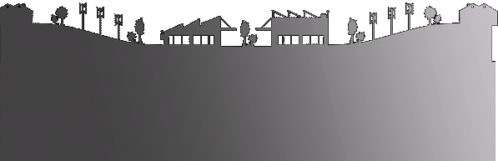

**Headquarters**

ZI n°3 - 78 rue du Kemmel – CS 20302

59429 Armentières Cedex - FRANCE

Phone. : +33 3 20 10 59 59

Fax : +33 3 20 35 57 22

**Spare parts catalogue**

**On request**